**Portfolio Management and Optimization Using Python**

**DATA 609 FEMDM – Winter 2025, University of Calgary**

**Authors**: Malhar Dhawle , Pawanjot Bath and Golin Chen

Table of Contents

**1. Introduction** 3

**1.1 Background and Motivation** 3

**1.2 Project Objectives** 3

**1.3 Report Structure** 3

**2. Theoretical Background** 4

**2.1 Portfolio Fundamentals** 4

**Portfolio Weights & Construction** 4

**Covariance Matrix** 4

**2.2 Risk and Return** 5

**Expected Portfolio Return** 5

**Portfolio Variance** 5

**2.3 Optimization Concepts** 5

**Minimum Variance Portfolio** 5

**CAPM Overview** 6

**2.4 Monte Carlo Simulation** 6

**3. Methodology** 7

**3.1** **Data Collection & Preparation** 7

**Data Preprocessing** 8

**Returns Calculation** 8

**Covariance Matrix** 8

**3.2 Portfolio Optimization Methods** 9

**Mean-Variance Optimization (MVO)** 9

**Monte Carlo Simulation** 10

**Minimum Variance Portfolio (MVP)** 10

**5. Results** 10

**Efficient Frontier** 12

**Conclusion**  12

**6. References** 13

## **1. Introduction**

### **1.1 Background and Motivation**

Given the unpredictable nature of financial markets, the complexity of investment decisions requires robust strategies. The challenge lies in identifying an asset allocation strategy which optimally distributes capital. A key aspect of financial management is portfolio optimization. Portfolio optimization is a process by which an investor makes the best selection of assets from the wide range of available options, aiming to maximize returns while minimizing risk. Harry Markowitz introduced Modern Portfolio Theory (MPT), which is rooted in portfolio optimization and emphasizes diversification's role in optimizing investment risk and returns. Portfolio optimization involves quantitative techniques, and the analysis of metrics related to the portfolio's expected returns, correlation and volatility. The objective of a well-optimized portfolio is efficient asset allocation and diversification, offering the highest expected return alongside mitigating risk. The importance of portfolio diversification relies on reducing volatility without compromising returns. The efficient frontier is a position where no other portfolio provides a better risk-adjusted return. Strategically combining assets with varying correlations allows investors to achieve an optimal portfolio that aligns with their investment goals and risk tolerance.

### **1.2 Project Objectives**

The primary objective of this project is to address the complexity of investment decisions by employing advanced mathematical and computational techniques to construct an optimal portfolio. This study aims to deliver a robust framework for investment decisions by analysing historical market data. By implementing the Mean-Variance Optimization (MVO), the optimal portfolio weight will be determined to maximize returns for a given level of risk. Constructing an efficient frontier allows individuals to identify the set of portfolios, offering the highest possible returns on a given level of risk. Later, Monte Carlo simulations are implemented to validate the portfolio performance. The final objective is to compare the outcomes of various portfolio optimization strategies, such as the Minimum Variance Portfolio (MVP) and Mean-Variance Optimization (MVO), to provide insights to investors. This project aims to comprehensively analyse portfolio performance and optimization methodologies by leveraging computational techniques.

### **1.3 Report Structure**

The report's structure starts with the theoretical background, which provides an overview of portfolio fundamentals, including portfolio weights, risk and return calculations, the role of covariance matrices and optimization concepts—moving onto methodology, which outlines the data collection process and computational methods used in portfolio optimization. This section outlines the implementation of various strategies. This report concludes with the results section highlighting the findings and a concise conclusion summarizing the key takeaways.

## **2. Theoretical Background**

### **2.1 Portfolio Fundamentals**

### **Portfolio Weights & Construction**

A financial portfolio is a collection of assets held by an investor, such as stocks, bonds, or other securities. The allocation of capital across different assets in a portfolio is determined by portfolio weights, which define the proportion of total capital invested in each asset. Mathematically, if a portfolio consists of assets, the weight of the $i-th$ asset is denoted as $w_{i}$, satisfying the constraint:

$$\sum_{i=1}^{N}{w_{i}} = 1$$

where can $w_{i}$ be positive (long positions) or negative (short positions). The set of all possible portfolios that can be formed with different weight allocations defines the attainable portfolios. The choice of weights influences portfolio risk and return, making the construction process critical for achieving investment objectives.

### **Covariance Matrix**

The covariance matrix is a fundamental component in portfolio theory, capturing the relationships between asset returns. For a portfolio with N assets, the covariance matrix $C$ is an $N ×N$ symmetric matrix where each element $C_{ij}$ represents the covariance between the asset $i$ and the asset $j.$

$$C_{ij }= Cov\left(r_{i,} r_{j}\right)$$

The covariance matrix possesses key properties:

* **Symmetry**: Since $Cov\left(r_{i}, r_{j}\right)= Cov\left(r_{j}, r_{i}\right)$ the matrix is symmetric.
* **Positive Definiteness**: The covariance matrix is positive definite were a symmetric matrix where all eigenvalues are positive. When no asset combinations result in negative variance, Positive Definiteness help ensuring meaningful risk assessments.

This matrix plays a crucial role in portfolio risk calculation, capturing asset interdependencies and enabling optimal portfolio construction.

### **2.2 Risk and Return**

### **Expected Portfolio Return**

The expected return of a portfolio, denoted as $μ_{v}$, is the weighted sum of individual asset expected returns. Given a portfolio weight vector and expected return vector $m$, the portfolio’s expected return is:

$$μ_{v}=w^{T}m$$

Where $w^{T}$ is the transpose of the weight vector This equation reflects how individual asset returns contribute to the overall portfolio return based on the assigned weights.

### **Portfolio Variance**

Portfolio variance measures the total risk of the portfolio and is computed using the covariance matrix $C$:

$$σ_{v}^{2}=w^{T}Cw$$

Here, $w^{T}Cw$ accounts for both individual asset variances and covariances among assets. A well-diversified portfolio minimizes variance by selecting asset weights that reduce overall risk through negative or low correlation between assets.

### **2.3 Optimization Concepts**

### **Minimum Variance Portfolio**

A minimum variance portfolio (MVP) achieves the lowest possible risk for a given set of assets. The optimal weight allocation for an MVP is determined by:

$$wMVP = \frac{C^{-1}1}{1^{T}C^{-1}1}$$

Where $C^{-1}$ is the inverse of the covariance matrix and is a vector of ones. This equation ensures the portfolio has the lowest possible variance while maintaining the entire investment.

**Efficient Frontier**

The efficient frontier represents a set of optimal portfolios that offer the highest expected return for a given level of risk. Portfolios on the efficient frontier dominate inefficient portfolios by providing superior risk–return trade-offs. The frontier's shape is concave, highlighting diversification benefits and the diminishing returns of increasing risk beyond a certain point. The efficient frontier consists of all portfolios on the minimum variance line whose expected return is greater than or equal to the expected return on the minimum variance portfolio.

### **CAPM Overview**

The Capital Asset Pricing Model (CAPM) describes the relationship between systematic risk and expected return given by:

$$E\left(r_{i}\right)= r_{f}+β_{i}\left(E\left(r_{m}\right)-r_{f}\right)$$

Where:

* $r_{f}$ is the risk-free rate,
* $E\left(r_{m}\right)$ is the expected market return,
* $β_{i}$ measures asset sensitivity to market movements.

The Security Market Line (SML) graphically represents this relationship, showing how assets with higher systematic risk ($β$) demand higher expected returns. The beta factor is calculated using the regression formula:

$$β_{v}= \frac{Cov\left(K_{v} , K_{m}\right)}{σ_{m}^{2}}$$

Where $K_{v}$ and $K_{m}$ are portfolio and market returns, respectively, and $σ_{m}^{2}$ is the market variance.

### **2.4 Monte Carlo Simulation**

**Purpose**

Monte Carlo simulation is a statistical technique used to model uncertainty in portfolio performance. Generating multiple hypothetical return scenarios assesses the probability distribution of portfolio outcomes, which is particularly useful for stress-testing portfolios under different market conditions and evaluating the impact of random fluctuations on investment returns.

**Basic Process**

The Monte Carlo simulation process involves:

1. Generating Random Returns: Simulate asset returns using assumed distributions (e.g., normal distribution with historical mean and variance).
2. Computing Portfolio Metrics: Calculate portfolio returns and risk using generated asset return samples.
3. Repeating Simulations: Run thousands of iterations to approximate the expected portfolio return and risk profile.

By analyzing the simulated results, investors can estimate confidence intervals for future portfolio performance, identify downside risks, and optimize asset allocations accordingly. The security market line is used to evaluate the impact of systematic risk, and stress testing can be applied by adjusting the assumptions regarding volatility and correlation structures.

## **3. Methodology**

## **3.1 Data Collection & Preparation**

For this project, we used **historical stock price data** from **Yahoo Finance**, which provides an Application Programming Interface (API) to access historical market data. The dataset includes key stock market indicators such as **Open, High, Low, Close, and Volume** for each stock.

We focused on **technology sector companies**, including **Amazon, Apple, Microsoft and Telsa.** The data spans **one year** of daily trading prices, allowing us to analyze recent market trends and construct an optimized portfolio based on real-world fluctuations.

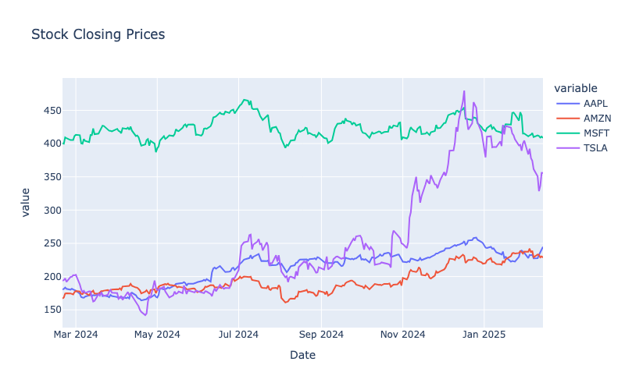

Figure 1

Figure 1 displays historical stock prices over one year. We can observe that companies like Microsoft and Apple have maintained steady growth with less volatility compared to companies like Tesla. It will be interesting to find out how our model allocates weights to these companies based on their price movements.

### **Data Preprocessing**

Once the data was collected, it was cleaned and structured for analysis. Any missing data points were removed, ensuring the dataset remained consistent. We also used closing prices for the day as the primary input for portfolio optimization. The dataset created using closing prices was reshaped to have dates from the index, with closing prices of stocks as columns.

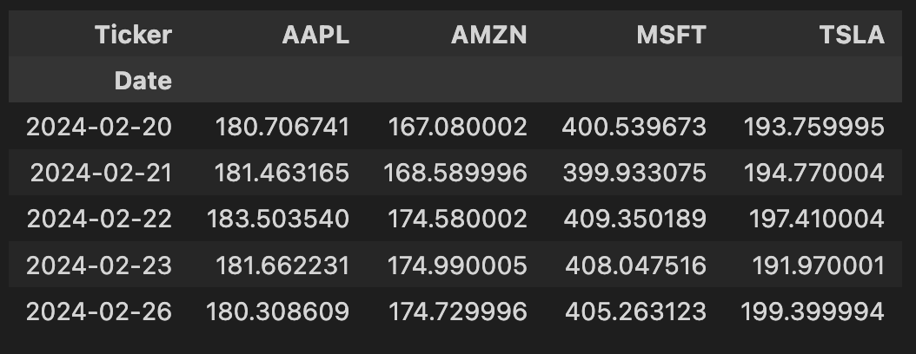

Figure 2

Figure 2 shows the format of the input data. It contains the closing prices of four stocks (AAPL, AMZN, MSFT, TSLA) on different dates.

### **Returns Calculation**

To analyze stock performance, we used logarithmic returns, which measure the percentage change in stock price over time. Logarithmic returns are additive in nature, making them useful for portfolio optimization.

$$\text{Logarithmic Return}=\ln\left(\frac{V_{t}}{V_{s}}\right)$$

### The pandas library in-built function is called pct_change(). It calculates the percentage change between the current and a prior element. These daily returns were **annualized**, given **252 trading days per year.**

### **Covariance Matrix**

To understand the **relationship between stock movements**, we computed the **covariance matrix** of returns. It helped us quantify how stocks move relative to each other. The covariance matrix was calculated using the **pandas ‘cov()’ function.** It is an **n×n symmetric matrix**, where each element represents the covariance between two stocks. The diagonal elements represent the **variance of each stock**.

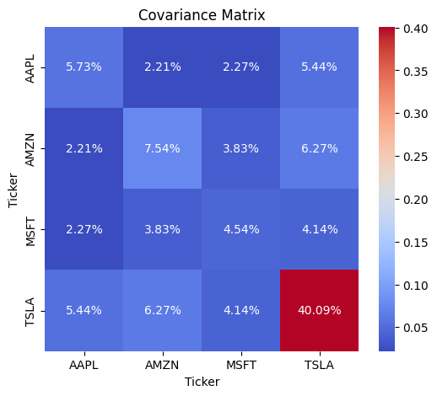

Figure 3

### The heatmap in Figure 3 shows the covariance matrix for each stock. We can observe that Tesla (TSLA) shows the highest variance of 40.09%, which indicates its high volatility compared to other stocks. Additionally, Apple (AAPL) and Microsoft (MSFT) share a relatively lower variance of (2.27%).

### **3.2 Portfolio Optimization Methods**

### **Mean-Variance Optimization (MVO)**

The Mean-Variance Optimization (MVO) model, introduced by Harry Markowitz (1952), aims to construct an efficient portfolio by balancing risk and return. MVO assigns weights to stocks based on their expected returns and covariance. To optimize the portfolio, we maximized the Sharpe Ratio, which measures risk-adjusted return:

$$\text{Sharpe Ratio}=\frac{E\left(R_{p}\right)-R_{f}}{σ_{p}}$$

Where $E\left(R_{p}\right)$ is the expected portfolio return, $R_{f}$ is the risk-free rate for which we have used 10-year US treasury bond yield and $σ_{p}$ is the portfolio standard deviation. We have used **Scipy’s ‘minimize()’ function** to find the optimal asset weights, which requires an o**bjective function and some constraints.** Since Scipy only supports minimize(), we **negated** the Sharpe Ratio to maximize it. The minimize function used Sequential Least Squares Programming (SLSQP) as the optimization method. The sum of weights was constrained to **1, and e**ach stock was limited to a **maximum of 45% and a minimum of 0%**, preventing excessive concentration in a single asset.

### **Monte Carlo Simulation**

### Monte Carlo Simulation is a statistical technique that uses random sampling to predict the probability of different outcomes. We used this technique to generate random weights for each stock in the portfolio. Using these weights, we calculated the annualized returns and volatility. This process was repeated multiple times to generate many random portfolios.

### This simulation allowed us to visualize the efficient frontier and identify the optimal portfolio. Unlike Mean-Variance Optimization, Monte Carlo Simulation does not require any constraints. To generate random weights, we used the Dirichlet distribution from the NumPy library since it generates random numbers that sum up to one.

### To evaluate the portfolio's performance, we calculated the Sharpe Ratio. This allowed us to visualize the efficient frontier and identify the optimal portfolio. The portfolio with the highest Sharpe Ratio is considered the optimal portfolio.

### **Minimum Variance Portfolio (MVP)**

**Minimum Variance Portfolio (MVP)** is designed to construct the lowest-risk portfolio. Unlike **Mean-Variance Optimization (MVO)**, which aims to balance risk and return, the MVP's main goal is to reduce variance. This makes it a good choice for risk-averse investors who prioritize stability over potential better gains.

The MVP strategy is grounded in **modern portfolio theory**, where risk is measured using the **covariance matrix** of asset returns. By appropriately weighting assets based on their variance and correlation structure, the MVP finds weights that minimize risks in the portfolio.

We use the inverse of the covariance matrix to derive the **optimal weights** for the **Minimum Variance Portfolio.**

$$\text{Weights}=\frac{C^{-1}⋅u}{u^{T}⋅C^{-1}⋅u}$$

Here, $C^{-1}$ represents the inverse of the covariance matrix, $u$ a vector of ones, ensuring equal consideration for all assets. The denominator ensures that the total weights sum to 1, maintaining a fully invested portfolio.

## **5. Results**

The portfolio weight allocations provide several key insights. Looking at Microsoft's (MSFT) closing price trend, we see a steady upward trend with relatively low volatility compared to other stocks. As a result, the Minimum Variance Portfolio (MVP) assigns Microsoft the highest weight of 50.61%, using its low volatility and consistent growth to lower the overall portfolio risk.

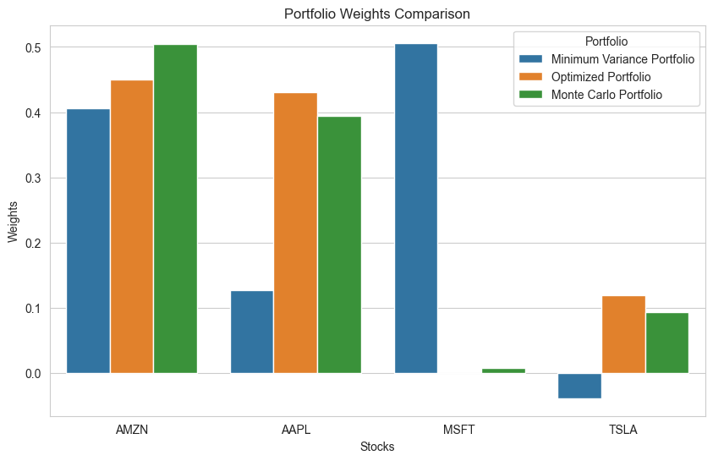

Figure 4

On the other hand, Tesla (TSLA) exhibits high volatility with large price fluctuations. To reduce its risk, the MVP takes a short position of -3.88% on Tesla, indicating that the model views it as a high-risk asset that could negatively impact portfolio stability. However, the Mean-Variance Optimized Portfolio (MVO) and Monte Carlo Portfolio still allocate between 9% and 12% to Tesla, considering its high return potential despite its volatility.

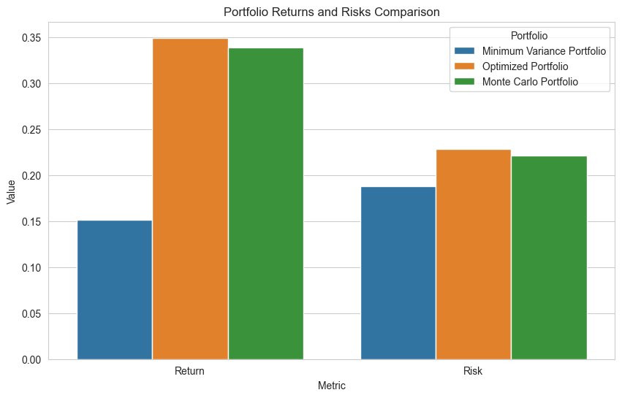

Figure 5

Figure 6

Additionally, **Amazon (AMZN) and Apple (AAPL) have been assigned significant weights across all portfolios** due to their **growth and relatively lower volatility**.

### **Efficient Frontier**

The efficient frontier is a set of optimal portfolios that offer the highest expected return for a given level of risk. We created it using a Monte Carlo simulation with 5000 iterations. The efficient frontier confirms that higher-risk portfolios tend to achieve higher expected returns.

The optimal portfolios are selected based on the Sharpe Ratio, which measures risk-adjusted return. The black "X" represents the portfolio obtained from the Monte Carlo simulation, and the green "X" denotes the Mean-Variance Optimized (MVO) Portfolio. The red star represents the Minimum Variance Portfolio (MVP), prioritizing risk over return.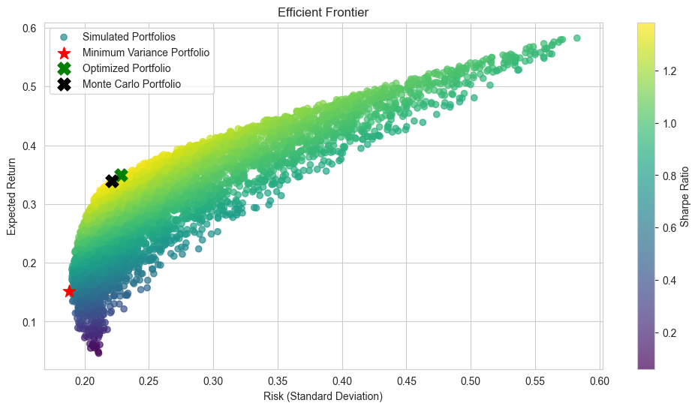

Figure 6

## The visualization shows that the MVP has the lowest possible risk and expected return. In contrast, the Mean-Variance Optimized Portfolio (MVO) achieves a higher Sharpe Ratio, offering better returns relative to its risk level. The Monte Carlo simulation also closely follows the MVO portfolio, demonstrating that random simulations can generate near-optimal results.

## **Conclusion**

This report demonstrates the effectiveness of portfolio optimization techniques. Valuable insights into asset allocation have been gained through the application of Mean-Variance Optimization, Monte Carlo Simulations, and the efficient frontier. The results validate academic beliefs. We have demonstrated how different portfolio optimization strategies can appeal to different investors.

* **Risk-averse investors:** MVP is the safest strategy while minimizing risk at the cost of lower returns and consistent growth.
* **Investors with a higher risk tolerance:** MVO and Monte Carlo Simulation provide the highest risk-adjusted return, confirming their effectiveness in portfolio construction.

The visualizations highlighted the importance of diversification, as the trade-off between risk and return is vital to ensuring effective portfolio allocation. Our findings in this study reinforce the importance of making financial decisions using effective strategies to ensure portfolio optimization.

Robust analysis has provided a solid foundation for portfolio optimization. Looking forward, we could potentially expand the analysis by including more assets, diverse data, and dynamic rebalancing strategies. Overall, the findings provide an insightful look at the trade-offs between risk and return, which allows investors to create informed, optimized portfolios based on their needs.

## **6. References**

Torres, L. F. (2023, December 5). *Portfolio optimization: The markowitz mean-variance model*. Medium. https://medium.com/latinxinai/portfolio-optimization-the-markowitz-mean-variance-model-c07a80056b8a#:~:text=The%20Markowitz%20Mean%2DVariance%20Optimization,compensated%20by%20higher%20expected%20returns.

*Numpy.random.dirichlet#*. numpy.random.dirichlet - NumPy v2.1 Manual. (n.d.). https://numpy.org/doc/2.1/reference/random/generated/numpy.random.dirichlet.html

Tom KealyTom Kealy 2. (1958, August 1). *Generating a list of random numbers, summing to 1*. Stack Overflow. https://stackoverflow.com/questions/18659858/generating-a-list-of-random-numbers-summing-to-1

*Portfolio optimization*. Financial Edge. (2024, September 10). https://www.fe.training/free-resources/portfolio-management/portfolio-optimization/#:~:text=Portfolio%20optimization%20is%20fundamental%20process,or%20the%20Black%2DLitterman%20Model.

*Efficient Frontier*. Corporate Finance Institute. (2024, May 22). https://corporatefinanceinstitute.com/resources/career-map/sell-side/capital-markets/efficient-frontier/#:~:text=Time%204%20minutes-,What%20is%20an%20Efficient%20Frontier%3F,or%20equal%20amount%20of%20risk.